

**2.3.1.AK Octal & Hexadecimal Number Systems**

Introduction

We all know that digital electronics use the binary number system. However, with new computers containing 32, 64, and even 128 bit data busses, displaying numbers in binary is quite cumbersome. For example, a single piece of data on a 64-bit data bus would look like this:

**0110100101110001001101001100101001101001011100010011010011001010**

Obviously, presenting data in this form would invite error. For this reason we use the hexadecimal (base 16) and, to a lesser extent, the octal (base 8) number systems.

In this activity you will learn how to convert numbers between the decimal, binary, octal, and hexadecimal number systems.

Equipment

* Calculator (preferably one with a number base conversion feature)
* Circuit Design Software (CDS)

Procedure

Complete the following **decimal-to-octal** number conversions. If available, use the base conversion feature of your calculator to check your answers.

1. 25 (10) = 31 (8)
2. 49 (10) = 61 (8)
3. 187 (10) = 273 (8)
4. 398 (10) = 616 (8)
5. 2879 (10) = 5477 (8)

Complete the following **octal-to-decimal** number conversions. If available, use the base conversion feature of your calculator to check your answers.

1. 36 (8) = 30 (10)
2. 75 (8) = 61 (10)
3. 143 (8) = 99 (10)
4. 367 (8) = 247 (10)
5. 1735 (8) = 989 (10)

Complete the following **decimal-to-hexadecimal** number conversions. If available, use the base conversion feature of your calculator to check your answers.

1. 25 (10) = 19 (16)
2. 46 (10) = 2E (16)
3. 120 (10) = 78 (16)
4. 429 (10) = 1AD (16)
5. 1215 (10) = 4BF (16)

Complete the following **hexadecimal-to-decimal** number conversions. If available, use the base conversion feature of your calculator to check your answers.

1. 3B (16) = 59 (10)
2. A9 (16) = 169 (10)
3. 159 (16) = 345 (10)
4. 2A3 (16) = 675 (10)
5. 1AB3 (16) = 6835 (10)

Utilize the shortcut base conversion technique to complete the following table.

|  |  |  |  |
| --- | --- | --- | --- |
|  | Binary | Octal | Hexadecimal |
|  | 1010112 | **53** | **2B** |
|  | **110100011** | **643** | 1A316 |
|  | 110101102 | **326** | **D6** |
|  | **1011111** | 1378 | **5F** |
|  | 1010111102 | **536** | **15E** |

A useful tool in simulation is the Digital Hex Display. Create the following circuit in the Circuit Design Software (CDS) and complete the truth table.

|  |  |  |  |  |
| --- | --- | --- | --- | --- |
| **A** | **B** | **C** | **D** | **Display?** |
| **0** | **0** | **0** | **0** | **0** |
| **0** | **0** | **0** | **1** | **1** |
| **0** | **0** | **1** | **0** | **2** |
| **0** | **0** | **1** | **1** | **3** |
| **0** | **1** | **0** | **0** | **4** |
| **0** | **1** | **0** | **1** | **5** |
| **0** | **1** | **1** | **0** | **6** |
| **0** | **1** | **1** | **1** | **7** |
| **1** | **0** | **0** | **0** | **8** |
| **1** | **0** | **0** | **1** | **9** |
| **1** | **0** | **1** | **0** | **A** |
| **1** | **0** | **1** | **1** | **b** |
| **1** | **1** | **0** | **0** | **C** |
| **1** | **1** | **0** | **1** | **D** |
| **1** | **1** | **1** | **0** | **E** |
| **1** | **1** | **1** | **1** | **F** |

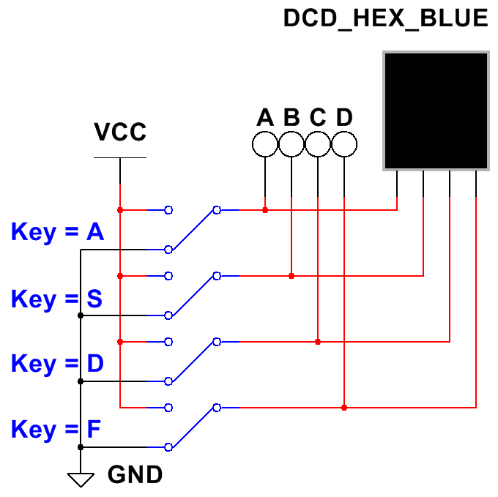

The HEX DISPLAY has a built-in decoder that converts a binary number into its corresponding display digit. For example an input of ‘0110’ would display a ‘6’, and a ‘1010’ would display an ‘A’.

Conclusion

1. Without performing the conversion, which of the following numbers is the octal equivalent of 24510? How were you able to determine this?

**You can eliminate (b.) because the octal number can NEVER be less than the decimal number, and eliminate (9a.) because there is no such thing as a 9 in octal.**

* 1. 3798
  2. 1748
  3. **3658**

**(3x64) + (6x8) + (5x1) = 245(10)**

1. You are sent to the store to buy some hamburger for dinner. When you come home, your sister looks at the UPC label on the meat and says, “We can’t use this.” What does she see on the label that you do not? Hint: think hexadecimal.

1011

1010

1101

1011

1110

1110

1111

**11=B 10=A 13=D 11=B 14=E 14=E 15=F**

**Going Further – Optional**

1. With 128-bit graphic cards becoming standard on many new PCs, there has been some thought of expanding to the base 32 number system. The base 32 number system would be selected because it is the next greatest power of two after 16. Use your knowledge of number systems to convert the following base 32 number into its decimal equivalent.

**323 322 321 320**

**32768 1024 32 1**

**4 x 32768 = 131072**

**25 x 1024 = 25600**

**8 x 32 = 256**

**22 x 1 = 22**

**176950 (10)**

4P8M (32) = **156950 (10)**